

Project Initialization and Planning Phase

|  |  |
| --- | --- |
| Date | 15 August 2024 |
| Team ID | LTVIP2024TMID24818 |
| Project Name | Toxic Comments Classification For Social Media |
| Maximum Marks | 3 Marks |

**Define Problem Statements (Customer Problem Statement Template):**

The project focuses on implementing toxic comment classification for social media using IBM services. Leveraging IBM's advanced natural language processing (NLP) capabilities, the system aims to identify and categorize toxic comments in real-time, enabling proactive moderation and fostering a safer online community environment**.**

**The User** is mainly focus on The rise of social media platforms has led to an increase in user-generated content, including discussions, debates, and interactions across a wide range of topics. While many of these conversations are constructive, there has also been a surge in toxic comments that can harm individuals and communities. Toxic comments can include hate speech, insults, threats, harassment, and other harmful content that negatively impacts users' experiences..

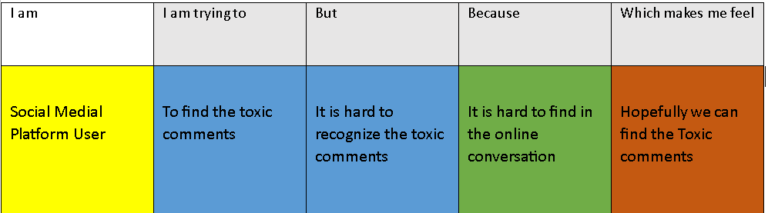

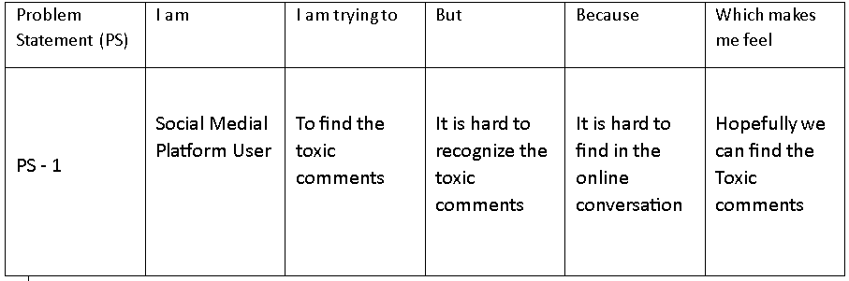**Problem Statement (PS):**

